**Name: STEBIN BABU**

**Roll No:44**

**Batch:B**

**Date:31-03-2022**

**NETWORKING & SYSTEM ADMINISTRATION LAB**

**Experiment No.: 1**

**Aim**.

Familarizarion of linux commands.

**Procedure**

**1.Touch**

touch command is a way to create empty files

Syntax: touch **<filename>**

Output:

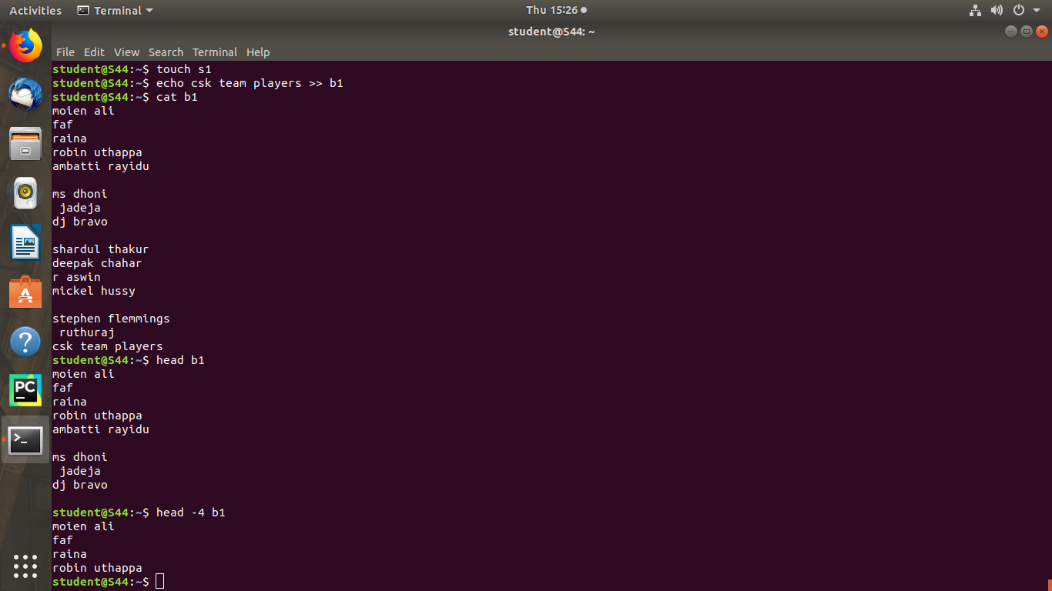

**2. Echo**

This command is used to add contents to the file.

Syntax :- $ echo content >> filename

Output :- Contents will be added to the file.



**3.head**

This command is used to display the first 10 lines of the file by default.

Syntax :- $ head filename

Output:-



**4.cat -n**

This command is used to specify the contents with line number.

Syntax :- $ cat -n filename

Output :-

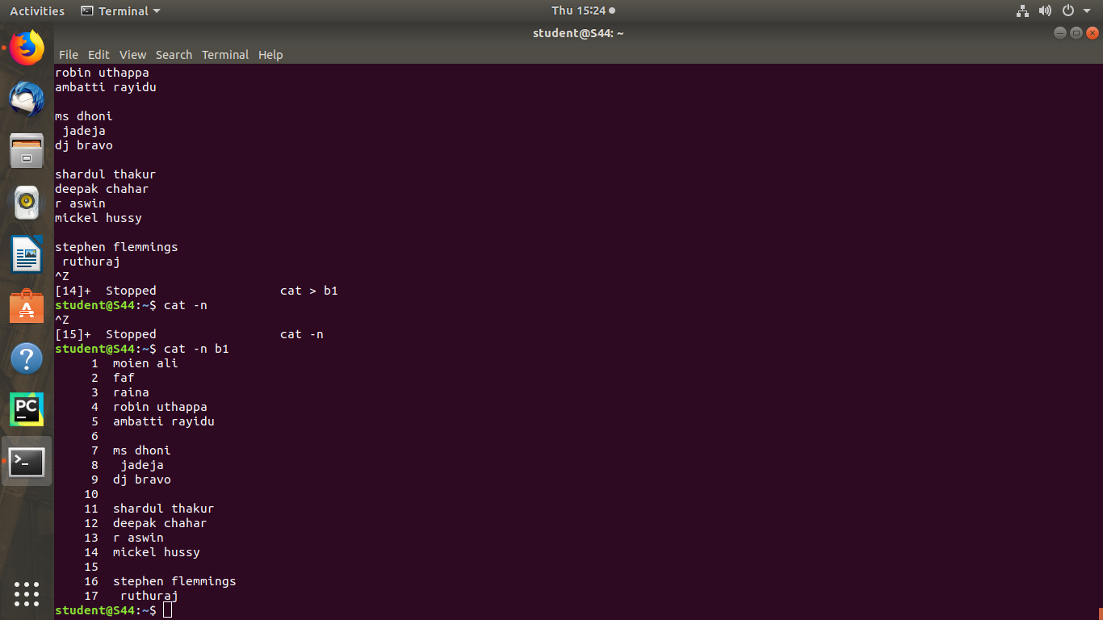

**5.cat -b**

This command is used to remove the empty lines from the file.

Syntax :- $ cat -b filename

Output :-

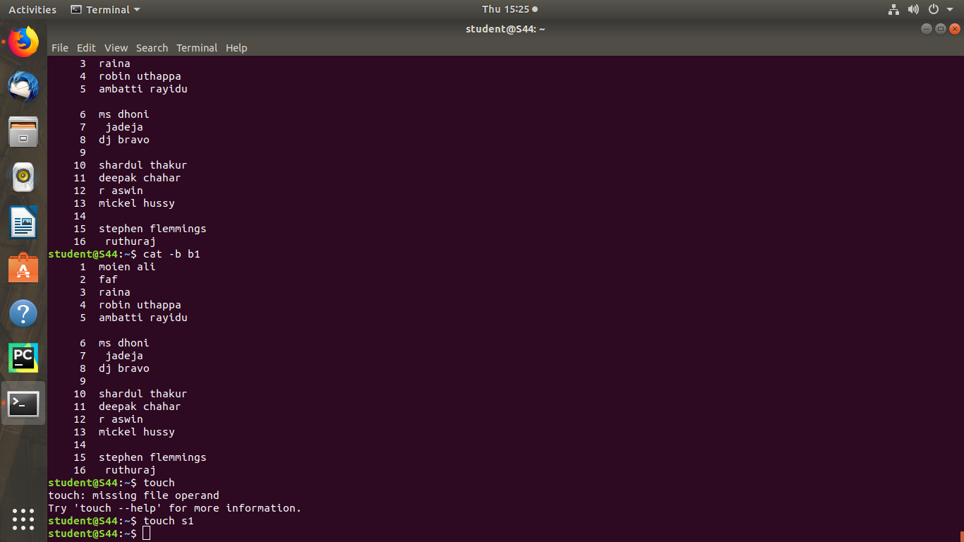

**6. head -number**

This command is used to display the lines of the file to the specified number from head.

Syntax :- $ head -number filename

Output :-



**7**.**tail**

This command is used to display the last 10 lines of the file by default. Syntax :- $ tail filename

Output :-

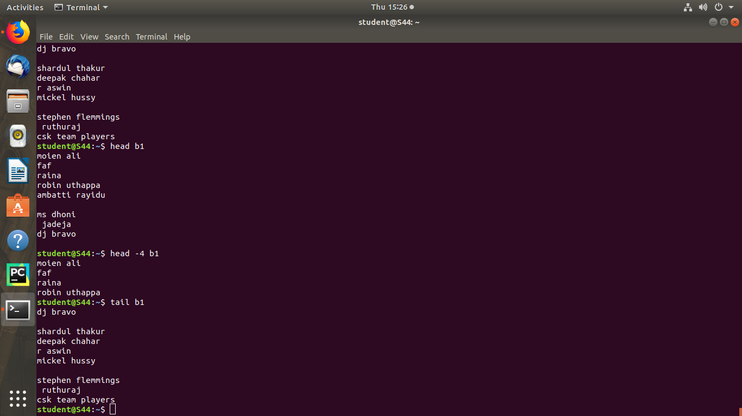

**8.tail -number**

This command is used to display the lines of the file to the specified number from tail.

Syntax :- $ tail -number filename

Output :-

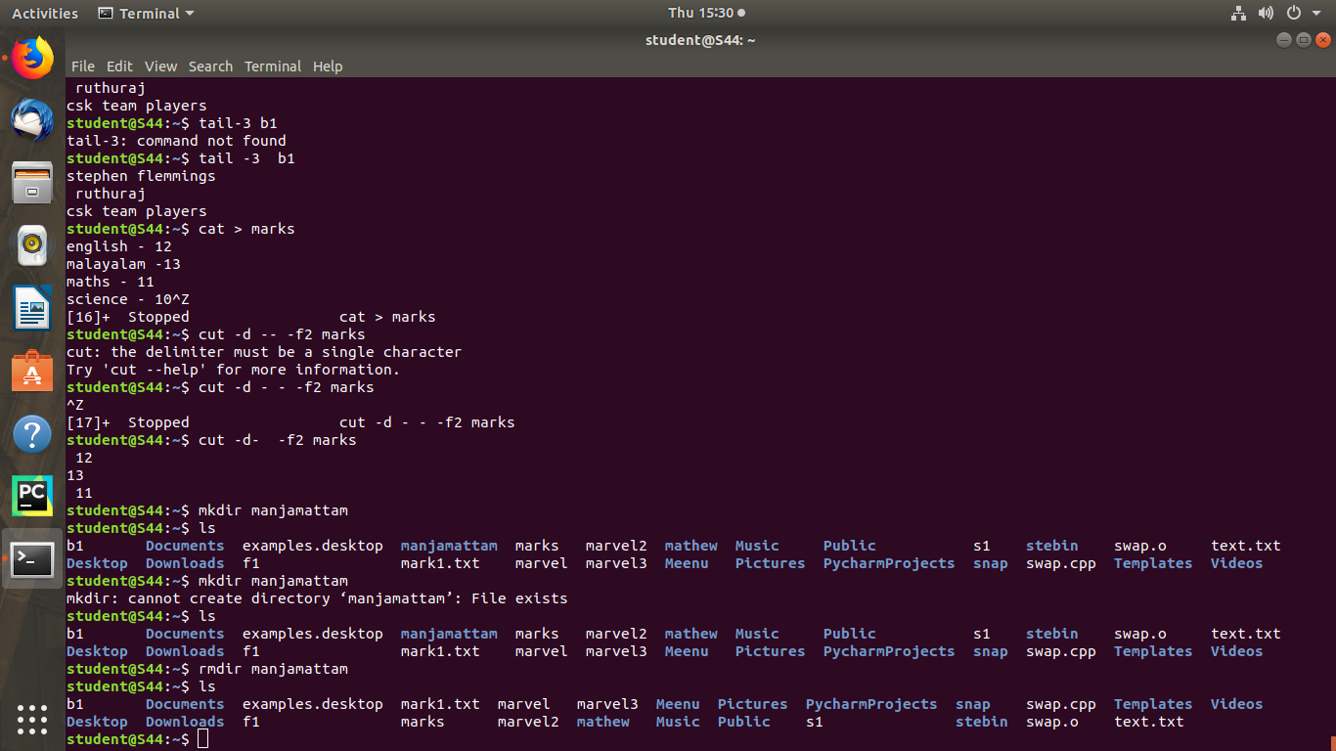

**9.cut -d- -f2**

This command is used to cut and the display the contents based on the delimiter given.

Syntax :- $ cut -d- -f2 filename

Output :-



**10.cut -d**

This command is used to cut and display the content based on the delimiter given.

Syntax :- $ cut –d delimiter –fieldnumber filename

Output :-

**11.cut -b**

This command is used to cut and display the content based on the specified byte number.

Syntax :- $ cut –b bytenumber filename

Output :-

**12. cut --complement -c**

This command is used to erase the specified character and display the remaining content of the file.

Syntax :- $ cut --complement –c characternumber filename.txt

Output :-

**13.paste**

This command is used to paste the contents from the specified file.

Syntax :- $ paste filename

Output :-

**14.paste file1 file2 > file3**

This command is used to paste the contents from the specified files to another file.

Syntax :- $ paste file1 file2 > file3

Output:-

**15.paste -s**

This command is used to paste the contents sequentially. It reads all the lines from the file and merges all these lines into a single line with each line separated by tab.

Syntax :- paste –s file1 file2

Output :-

**16.paste -d**

This command is used to paste the contents from the given files with the delimiter given.

Syntax :- $ paste –d delimiter file1 file2

Output :-

**17.more**

This command is used to view the text files in the command prompt, displaying one screen at a time in case the file is large.

Syntax :- $ more filename

Output :-

**18.more -number**

This command is used to display display the lines to the specified number from head.

Syntax :- $ more -number

Output :-

**19.more +number**

This command use the line number from where we want to displaying the text content.

Syntax :- $ more +number

Output :-